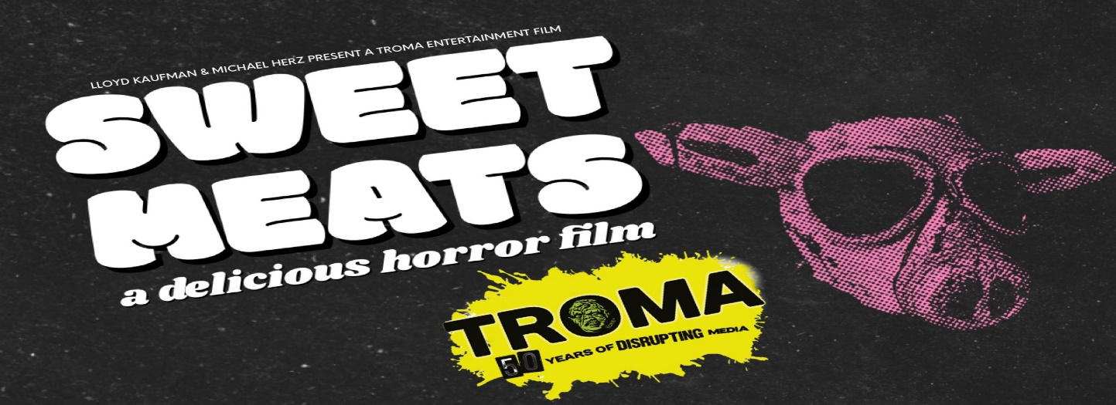
FOR IMMEDIATE RELEASE – Sweet Meats, a brand-new horror movie from Lloyd Kaufman & Michael Herz and Troma Entertainment, Horror House Pictures LLC, P.J. Starks and NKY Films.

MEDIA CONTACT: PJ Starks (Executive Producer) starks.pj@gmail.com, Lloyd Kaufman (Executive Producer) slloydk@gmail.com , Ricky Glore (Writer/Director) ricky.glore@gmail.com

“Throwback Horror Movie in the style of MOTEL HELL meets Roger Corman’s LITTLE SHOP OF HORRORS”
SYNOPSIS: Bobby Sweet is a country music legend and has been the world-renowned face of "Sweet Meats" since establishing his first restaurant with his wife in 1978.
How did his restaurant take off so quickly and what makes the meat so darn sweet?
Sometimes a "secret ingredient" should stay that way. They always say, "you'd be disgusted if you knew what you were really eating!" They might be right...
ABOUT THE PROJECT: NKY FILMS is proud to bring to life the story of Bobby Sweet and show that "elbow grease" isn't just a saying, but also a flavor. Writer/Director Ricky Glore (All Your Friends Are Dead) will helm Sweet Meats and it will be filmed in Wilder, Kentucky at Bobby Mackey’s, the infamously haunted slaughterhouse featured on Travel Channel’s Ghost Adventures as well as Nick’s Restaurant in Harrison, Ohio. Special Effects by Lizzie Schreibeis (U.S.S. Nightmare) with wardrobe by Ashley Meenach (Hauntology, Monica). Nicholas Hiance (All Your Friends Are Dead) will serve as director of photography. The film is produced by PJ Starks (New Fears Eve), Chris Morris (All Your Friends Are Dead), Mike Flinchum (Hell’s Gate). The score will be conducted by David Kornfeld, the Jeff Award-winning composer of HAYMARKET: A NEW FOLK MUSICAL and he is currently on tour as Associate Conductor of the Jagged Little Pill Broadway musical.

Lloyd Kaufman & Michael Herz (The Toxic Avenger, Mother’s Day) and Troma Entertainment are producing as well as distributing the film.

Sweet Meats has an exciting and talented cast featuring Timmy Barron (Chicago Fire), Eileen Earnest (All Your Friends Are Dead), Andrew Gordon (The Forest Hills, Amityville Karen), Amanda Chilelli (Playboy Playmate) and Ricky Glore (All Your Friends Are Dead & Dry Bar Comedy)

FOR MORE INFORMATION & TEASER:
Indie Go Go: https://www.indiegogo.com/projects/sweet-meats-horror-feature-film#/

